
February 23, 2013
Craig Olson
200 S Chelsea Park Pl.
Tucson AZ 85748

Dear Craig Olson:
We greatly appreciate you choosing Northern Arizona University as your outlet in developing this one of a kind project. We understand that you had many other outlets to choose from and we will not disappoint you in the coming months. Our goal is to develop a mass spring damper system capable of adapting to different environmental changes using Magneto Rheological fluid which will satisfy your specification and requirements.
At this time we would like to invite you to the Capstone Design Conference the day of April 26th, 2013. By early April 2013, more details of when and where our presentation and poster session will take place will be submitted to you.
This status report has a single significant design requirement change: the front fork size. Initially the project team began designing a MR damper based on a standard 32 mm stanchion fork. The fork obtained for the project has a 35 mm diameter stanchion.
To date, we have obtained an applicable front fork and have designed and constructed a MR damper to fit said fork. We have also obtained and interfaced all electronic components necessary to control MR fluid through the constructed damper.
We have yet to obtain MR fluid for the project. Multiple MR fluid manufacturers have denied contributing fluid to our project, or selling an affordable amount of fluid. Also, we cannot fit the fork to an actuator to test the open loop response of the fork.
Our main concern at this point of the project is obtaining MR fluid. Please respond to Michael Doty (mcd62@nau.edu) with any suggestions you have regarding this matter.

Submitted by:  Mcd62@nau.com  Waa8@nau.edu  Rso6@nau.edu  Amr76@nau.edu |  | Date: 2/23/2013



Electro Magnetic Shock Team
Name | Email | Phone | Address
Michael Doty | mcd62@nau.edu | 661-600-5762 | 24612 Garland Dr. Valencia, California 91355
Ryan Olson | rso6@nau.edu | 520-256-5788 | 800 W. Forest Meadows #292 Flagstaff, AZ 86001
Adrian Ortega | amo76@nau.edu | 928-699-2856 | 3200 S. Litzler Dr #1-102 Flagstaff, Arizona
Waleed Alzahrani | waa8@nau.edu | 928-814-4084 | 923 University Ave, apt 251, Flagstaff, Arizona 86001

Technical Advisor: Dr. Constantin Coicanal
Table of Contents
Executive Summary ii
Project Description 1
Problem Definition 1
Research Survey Results 2
Coil Spring/Air Spring 3
Mono-Tube Oil Damper 3
Twin-Tube Oil Damper 3
Oil Damper Valve Assemblies 4
Mountain Bike Suspension Systems 5
Cannondale Simon 6
Magnetorheological Fluid 6
MagneRide 7
MR Fluid as Damper Oil in MTB Suspension 8
References 9
Requirements and Specifications 10
Mechanical 10
Electrical 10
Environment 11
Documentation 11
Testing 11
Comprehensive Testing Plan: 12
Design 13
MR Fluid 13
MRF-122EG 14
MRF-132DG 16
MRF-140CG 19
MR Fluid Decision Matrix 21
Size Constraints 23
24
Since the initial size constraints were developed during the Fall semester of 2012, the project team has acquired a Marzocchi Bomber 55 ATA front mountain bike fork (Figure 18). The Bomber 55 has outer stanchion diameter of 35 mm. Although the bomber 55 has greater stanchion diameter, the damper housing cartridge remains 24 mm, making the Bomber 55 compatible with the designs developed last semester. 24
Piston Head 24
Electromagnet 27
Accelerometers 28
Microcontroller Unit 29
Electronic Control System 30
Voltage Controlled Current Source 31
Schedule/Deliverables 33
References 38
Acceptance Document 39
Point of contact 39
Liability 39
Ownership 39
Proposal Changes 39
Continued Support and Work 39

Executive Summary
Executive Summary
Five major design concerns/selections for the project include: magneto rheological (MR) fluid, electromagnet, piston head, accelerometers, and the microcontroller unit (MCU).
The MR fluid MRF-140CG manufactured by LORD Corporation will be the damper oil used to control the damping of the mountain bike suspension system. MRF-140CG is able to respond instantly and reversibly when acted on by a magnetic field. An electromagnet is responsible for generating the magnetic field through the MR fluid. The piston head will be fabricated in lightweight aluminum with orifices to allow MR fluid flow. Accelerometers will be utilized to sense the various forces acting on the suspension system. These accelerative forces will be processed to determine the desired response of the MR fluid. The MCU will process the accelerative forces and make intelligent decisions on the amount of current to output to an electromagnet.
The resulting mountain bike damper design will be fully active and adapt to any riding terrain in microseconds. The use of MR fluid as a damper oil allows for infinite customizability. The goal is to meet or exceed all design requirements specified in the requirements and specifications section of this proposal.
Schedule/Deliverables
The project schedule will consist of eight different phases: research, client, prototype, presentation, online documentation, meeting, proposals, and testing. The research phase has been concluded. The final deliverable package will include: all documentation, design notes, research results, schematics, diagrams, drawings, and prototypes. At the time of completion, on May 10, 2012, all items pertaining to the project will be property of the client.
Budget
An MR damper will be designed at the lowest cost possible. Cost will be a factor in every product purchasing decision. Our current estimated costs exceed $1000.00. The final budget and payment arrangements will be discussed and agreed upon prior to any activity.

Project Description

Problem Definition
The primary objective of this project is to determine the suitability and feasibility of using
magneto rheological damper technology as part of an actively controlled bicycle suspension system. The goal of this investigation is to create a laboratory system that demonstrates the ability to influence damping characteristics from external computer controls and to create a conceptual design of the hardware/software/algorithms that would be needed for prototyping.

There are over 5 million Mountain Bikes (MTBs) sold each year in this country alone. The suspension system is a significant driver of overall performance and unit cost. Any improvements that enhance performance or reduce cost would have a huge market potential. Of particular interest is the use of magneto rheological damper technology as part of a MTB suspension system. Magneto rheological (MR) fluid is a magnetic fluid that changes viscosity in the presence of a magnetic field. An electromagnet is used to change the viscosity of MR fluid. MR fluid is used as a damper in shock absorbers. When MR fluid is brought into a magnetic field, the metal particles in the fluid are aligned according to the magnetic field lines [1]. The stronger the magnetic field, the higher the viscosity of the MR fluid.
An electromagnet is used to control the viscosity of MR fluid. MR fluids adapt accordingly to sensors monitoring ground conditions. An accelerometer could be used to detect various ground conditions. The MR damper would respond according to information from the accelerometer. Algorithms could be used to interpret the accelerometer data. The algorithms would determine how much current to send through the electromagnet. The electromagnet would then attenuate the viscosity of the MR fluid.
Figure 1[2][3] shows a basic depiction of the various parts of the system.
Bycycle Fork
Current Output to Electromagnet
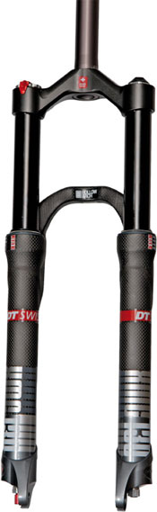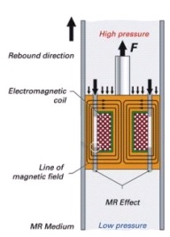
Accelerometer
Accelerometer
Control System
Figure 1. Block Diagram of the System
An accelerometer will be placed at the base of the fork near the front wheel. Impulses detected by the accelerometers are sent to a control system. The control system is a microcontroller with firmware programmed into it. The firmware consists of algorithms which interpret information from the accelerometer. The algorithms will determine how much current to send through the electromagnet. The electromagnet is used to control the viscosity of MR fluid. The viscosity of MR fluid will determine the damping characteristics of the suspension system.

Research Survey Results
This project and report will address suspension systems regarding mountain bikes (MTBs). The primary purpose of the MTB suspension system is to assist the rider in retaining maximum control by maintaining wheel contact with the ground when the bike is ridden over uneven terrain. The system does this by absorbing the energy (shock) generated when the bike encounters an obstacle in order to prevent that energy from being transferred to the rider. The shock absorbers consist of two parts; a spring and a damper. The spring (which can be either a conventional wire coil or pressurized air) provides the force necessary to return the system to the extended (retracted) position. The damper is the mechanism that dissipates the generated kinetic energy and flattens shock impulses. Each system is housed in a separate stanchion (or fork arm) of the mountain bike fork. Figure 2 shows the basic physics involved in a spring/mass damper system.

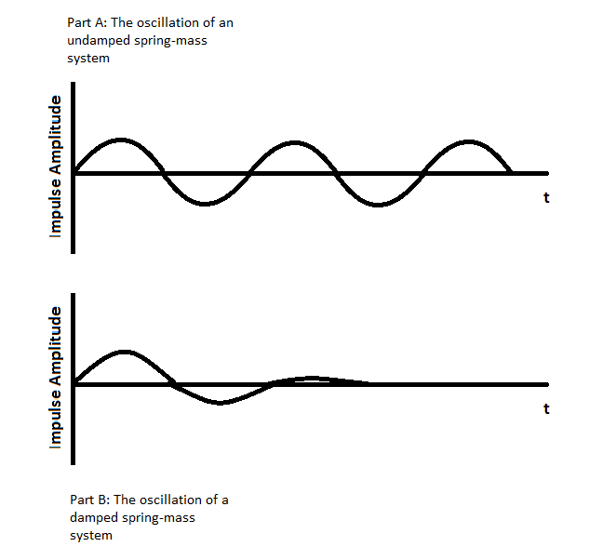
Part A shows the effects of a spring oscillating harmonically in time in response to an applied force. The dampers smooth out the spring oscillations, as seen in
Figure 2. Oscillation of an undamped (Part A) and damped (Part B) spring-mass system over time.
part B.

Many types of dampers have been used in MTB suspension systems. The most basic type is a simple friction damper which uses a stationary cylinder that rubs on the station tube as it moves in response to an applied force. The type most commonly used dampers are oil dampers. Oil dampers convert energy to heat through the frictional forces that occur when hydraulic fluid is forced through a constricted orifice. Oil damper configurations used on mountain bikes include: mono-tube oil dampers and twin-tube oil dampers. The state-of-the-art MTB dampers are sophisticated, well designed devices that include many intricate mechanical valves in order to achieve the desired damping characteristics. Advanced automotive suspension systems now use MR fluid in their dampers. MR fluids can be used in conjunction with electrical sensors to provide real-time optimization of the damper characteristics. Because of these characteristics, it would be desirable to use MR fluids in MTB suspension applications as well.

Coil Spring/Air Spring
Coil springs are typically constructed from steel; however, titanium is sometimes used in MTB applications in order to save weight. Coil springs can be designed to achieve a linear spring rate (change in spring force divided by change in distance), or they can be configured to have a progressive spring rate. For a linear spring rate, the force required to compress a coil remains the same throughout the stroke of the spring, whereas a progressive spring requires an exponentially increasing force to move through its stroke. An air spring is a sealed chamber filled with compressed air. When acted on by a force, a piston inside the chamber further compresses the air to arrest the applied force and reverse the motion of the piston. Air springs possess a progressive spring rate; however, by increasing the volume of the air cylinder a more linear response can be achieved. Coil springs typically provide greater durability and responsiveness compared to air springs. Air springs offer greater adjustability and lighter weight.

The spring provides the restoring force needed to return the system back to the retracted (uncompressed) position. The rate at which it retracts is a function of the spring rate and the amount of rebound damping applied. Too little rebound damping and the fork will retract too quickly, possibly bouncing the wheel off the ground, throwing the rider off balance, or providing poor traction. Too much rebound damping and the fork will not open fast enough to respond to the next impact and will give a harsh ride[4].

Spring sag is a term that defines the distance the suspension compresses due to rider weight. Sag is needed to allow for overshoot that occurs as the suspension settles back to its extended position. Optimal sag is typically 20-25% of the full travel of the suspension. Sag is adjustable based on rider weight and preference. Sag is controlled by spring pre-load for a coil spring and air pressure for an air spring system[4]. Since spring rate is an inherent property of a particular coil spring design, the coil must be replaced in order to alter spring rate. Several suspension systems offer preload adjustments which allow the rider to manipulate rebound damping and sag by turning a knob. Air springs adjust rebound rate and sag through air pressure. More air pressure equates to a stiffer shock, which means a faster rebound rate and less sag. A shock pump is used to adjust air pressure in an air shock.

Mono-Tube Oil Damper
An image of a mono-tube oil damper can be seen in Figure 3. Mono-tube dampers consist of a single cylinder filled with oil and high pressure gas. The cylinder also houses a piston with valves. During compression, oil is forced through the valves on the piston. Kinetic energy is converted into heat due to the friction of the oil flowing through the valves. A floating piston provides a physical barrier between the damper’s oil and the high pressure gas needed for shaft displacement [5]. Nitrogen, which is stable under high heat, is often used as the low pressure gas.

Twin-Tube Oil Damper
An image of a twin-tube oil damper can be seen in Figure 3 [6]. Twin-tube dampers consist of an inner and outer cylinder. The inner tube is filled with oil. The outer tube is a reservoir which is partly filled with oil and low pressure gas. The inner tube also houses a piston with valves. During compression, oil is forced through the valves on the piston. Kinetic energy is converted into heat due to the friction of the oil flowing through the valves. Another base valve allows oil to flow from the inner to outer tube due to oil displacement from the piston rod. Hard working dampers create high temperatures. Like mono-tube dampers, Nitrogen is often used as the low pressure gas. During extension, the gas forces oil in the outer tube back into the inner tube. At high temperatures, damper oil begins to foam, which causes the oil to become more viscous. Foaming is especially apparent with twin-tube dampers. The high pressure in mono-tube dampers prevents damper oil from foaming. The Nitrogen helps to prevent foam from forming with twin-tube dampers.
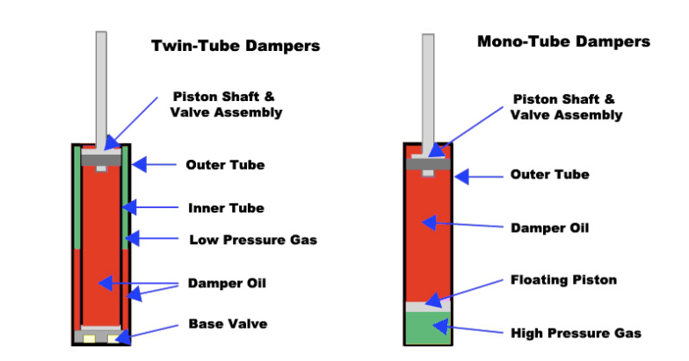
Figure 3. Twin-Tube vs Mono-Tube Dampers

Oil Damper Valve Assemblies
Valves regulate oil flow through orifices in the piston head. Many valving schemes exist for dampers. Shim stacks are primarily used as valves for MTB dampers. A shim stack is a series of thin washers which constrict or increase the amount of oil allowed through a damper orifice. Figure 4 [7] shows how a shim stack works.
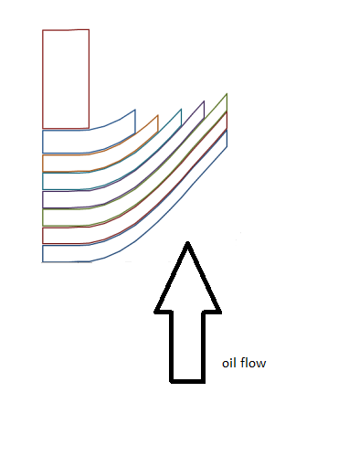
Figure 4. Shim Stack Behavior Due to Oil Flow
At low speed collisions, suspension is stiff and shim stacks remain flat, constricting oil flow through an orifice. At high speed collisions, suspension is soft and shim stacks fold open, allowing more oil to flow through an orifice. Shims can be bought with various widths and diameters. Different size shims generate varying valve control. Separate shim stacks control compression and rebound damping.

Mountain Bike Suspension Systems
Edited since November 6, 2012
MTB suspension systems have undergone significant improvements over the last 15 years. Mountain bikes fall into four basic categories; cross country, all mountain, freeride and downhill. The suspension for each category is optimized for its particular application. The cross country design typically use 100 mm of travel and the design is driven by the need for light weight and peddling efficiency. On the other end of the spectrum, Downhill bikes use 200 mm or more of travel and are optimized for big hits at high speeds. The current state-of-the–art systems use hydraulically damped air spring designs that incorporate external adjustments for compression damping, rebound damping and air spring pressure. However, despite the adjustment capabilities, optimal performance cannot be achieved over all riding conditions that are experienced.
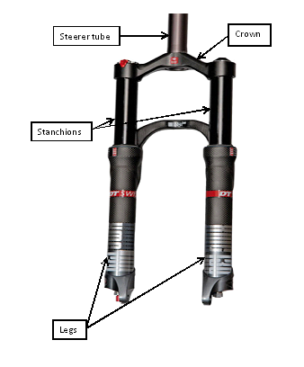
There are hundreds of different damper and spring combinations available to MTB riders. MTB suspension systems range from tens to thousands of dollars. Quality MTB suspension systems are available for cheap; however, low end systems typically do not offer variability for rider preference. High end systems offer adjustments for compression/rebound damping, sag, ride height, lockout and many other modifications. Suspension systems such as Cannondale’s Simon attempt active electronic control over suspension characteristics.

As seen in figure 5[2], a mountain bike fork consists of four parts: legs or lowers, stanchions, the crown, and the steerer tube. The legs are typically cast out of magnesium. At the bottom of the legs are brackets used to mount the front wheel. These brackets can be for a through axle, or as seen in Figure 5, a quick release axle. Inside the legs are bearings called bushings. Bushings allow the stanchions to easily slide inside the legs. Stanchions are typically made of aluminum. Inside the stanchions is the suspension system. Typically, the right stanchion contains the spring while the left stanchion houses the damper. Stanchions range in inner diameter sizes of 32-40mm. So stanchions do not move independently, they are locked together by the crown. The crown also connects the stanchions to the steerer tube. The steerer tube connects the entire fork and front wheel to the handle bars.
Figure 5: Mountain bike fork

Cannondale Simon
Simon is a prototype active suspension system for mountain bikes from Cannondale. Simon is an electronically controlled twin-tube oil damper suspension system. Simon damper is simple from a mechanical standpoint, consisting of a single solid piston pushing oil back and forth through just one orifice [8]. A retractable pin, controlled by a fast acting Cannondale-exclusive linear stepper motor, adjusts the size of the port, which can go from full-open to full-closed in just six milliseconds [8].

The heart of the system is a CPU, which analyzes and processes information from sensors located at the base of the fork [9]. The accelerometer near the axle of the front wheel detects ground conditions. The accelerometer information is processed by the CPU which sends commands to the stepper motor. The CPU processes the information coming from the sensors at a rate of 500 times per second [9].

Simon has five preset riding modes available: mountain, cross country, downhill, travel management, and lockout. The Mountain mode is very similar to a standard mountain bike damper. Cross country mode is a stiff suspension designed for racing. Downhill mode is a soft suspension which provides the largest amount of travel available. Travel management mode is used when climbing hills. The amount of travel in the front shock is decreased so as to reduce the weight applied on the rear of the bike. Lockout mode forces the shock to become rigid, and is used for riding on paved roads where peddle bob is unwanted. Lockout mode can still react to various road conditions such as potholes, and increases damping as needed.

Users interact with Simon through a switch on the handlebar and an LCD screen at the top of the fork. Different riding modes can be selected while riding.

Magnetorheological Fluid
Edited since November 6, 2012
MR fluid is a smart fluid that is finding its way into our everyday lives. MR fluid is currently being used in devices such as clutches, brakes, dampers, and even body armor. Uses for MR dampers include vibration and shock impulse elimination in appliances such as washers and dryers, seats, airplane engines and automobile suspension. MagneRide is a cutting edge suspension system which uses MR fluid as its damper oil.

Magnetorheological (MR) fluid is hydrocarbon oil with iron particles suspended in it. Size of the iron particles is typically between 3-5 microns. The iron particles are suspended using a suffocant, which does not allow the particles to settle or clump together. The suffocant also reduces the abrasive properties of the iron particles. When MR fluid is in the presence of a magnetic field, polarization is induced in the suspended iron particles. The interaction between the resulting induced dipoles causes the particles to form columnar structures, parallel to the applied field, as shown in Figure 6 [10][11].
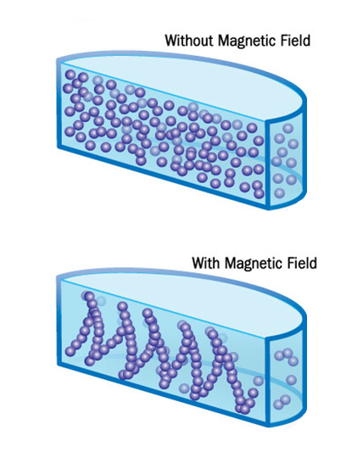
Figure 6: MR fluid without/with magnetic field applied
These chain-like structures restrict the motion of the fluid hence increase the viscous characteristics of the suspension. In essence, MR fluid behavior transforms from that of a liquid to that of a solid-like gel when an external magnetic field is applied [11].

MagneRide
Car manufacturers that currently use MR fluid in suspensions systems include GM, Honda, BMW, Ferrari, Audi, and many others. Aside from BMW (which uses a proprietary version of MR damping), other car manufacturers which use MR damping essentially use the same system, MagneRide. MagneRide is a semi-active suspension system utilizing MR fluids. Developed by the Delphi Corporation, the MagneRide debuted on the Cadillac Seville STS in 2002. MagneRide technology is now owned by Beijing West Industries (BWI). Figure 7 [3] shows the basic structure of the MagneRide MR damper.
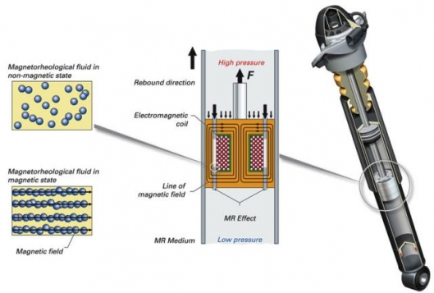
Figure 7. MageneRide MR Damper

Seen in Figure 7[2] are the narrow channels, which MR fluid flows through. When the electromagnetic coils are not powered (when no magnetic field is present), MR fluid is free to flow through the channels, as the fluid is in a non-magnetic state. With the electromagnetic coils turned off, MR fluid easily flows through the channels, generating a softer response from the shock. When the electromagnetic coils are powered, a magnetic field is produced with magnetic flux lines as shown in Figure 7[2]. In the presence of a magnetic field, MR fluid enters a magnetic state. The iron particles in MR fluid bond in the direction of the magnetic flux lines. The bonds of the iron particles impede the flow of MR fluid, generating a stiffer response from the shock.

MR Fluid as Damper Oil in MTB Suspension
As seen with MagneRide, MR dampers are already being used in automotive applications. MR dampers could also be used in MTB applications. MR fluid could provide a simple, elegant solution to a mountain bike damper industry that has spent hundreds of millions of dollars designing complex oil dampers using shim stacks and other mechanisms to control oil flow. Complicated valving is not needed with MR dampers; instead, an electromagnet is used to control oil flow. An electromagnet allows infinite adjustability. An electromagnet and sensors detecting uneven terrain can instantly, in real time, actively control suspension systems.

References

[1] Wikipedia. (2012). Magnetorheological fluid [Online]. Available: http://en.wikipedia.org/wiki/Magnetorheological_fluid

[2] BESPORTIER. (2010). Best mountain bike forks – quality mountain bike forks – DT swiss XMC [Online]. Available: http://www.besportier.com/archives/best-mountain-bike-forks-quality-mountain-bike-forks---dt-swiss-xmc.html

[3] Mike Hanlon. (2006). Audi’s new magnetic semi-activesuspension system [Online]. Available: http://www.gizmag.com/go/5752/

[4] Cycle Monkey. (2010). Mountain bike suspension 101 [Online]. Available: http://www.cyclemonkey.com/suspension_101.shtml

[5] Jay Chen et al. (2006). Making it stick part 6 – monotube dampers [Online]. Available: http://www.modified.com/tech/0607_sccp_making_it_stick_part_6/viewall.html

[6] MeisterR. (2012). Suspension: different springs, monotube vs twintube dampers Online]. Available: http://www.skylineowners.com/forum/showthread.php?p=1964330

[7] Shim ReStackor. (n.d.). Restackor sample applications [Online]. Available: http://www.shimrestackor.com/Code/Sample_Applications/Stack_Config/stack-config.htm

[8] James Huang. (2009). Interbike: cannondale debuts simon suspension concept [Online]. Available: http://www.bikeradar.com/news/article/interbike-cannondale-debuts-simon-suspension-concept-23332/

[9] Luca Salvatelli. (2009). The new cannondale simon lefty fork [Online]. Available: http://www.ciclonline.com/eng/technique/228-cannondale/413-the-new-cannondale-simon-lefty-fork.html

[10] Tracy V. Wilson. (2007). How liquid body armor works [Online] Available: http://science.howstuffworks.com/liquid-body-armor2.htm

[11] M. Kciuk et al. (2009, April). Magnetorheological characterization of carbonyl iron based suspension (Vol. 33, Issue 2) [Online] Available: http://www.journalamme.org/papers_vol33_2/3323.pdf

Requirements and Specifications

Mechanical
A standard mountain bike fork will be used which should accommodate for a 26 inch wheel. The entire suspension system should be light weight. No toxic or hazardous materials shall be used in the design. System failures shall be considered and precautions must be taken in order to mitigate harm to the user.

Table 1. Mechanical Requirements
Weight | Less than 6 lbs (total fork weight).
Wheel Spacing | 110 mm.
Steerer Tube Diameter | 1.125 in.
Steerer Tube Length | 9 in minimum.
Suspension Travel | 5 – 6 in (125 – 150 mm) minimum.
Wheel size | 26 in diameter.
Axel Size | 15 mm thru axel design.
Fork Tube Diameter | 32 – 36 mm.
Spring | Air spring.
Brake Mounting | Post style disc brake mount.
Operating Loads | 25 – 85 lbs.

Electrical
The electronics shall utilize accelerometers to sense operating forces, determine optimal damping, and generate a signal to control the magnetic flux density across the damper. The electronics should be small enough to be mounted on the bicycle’s handlebars. The microcontroller should consume little power. The microcontroller shall be capable of processing sensor inputs and providing control signal outputs at a high rate. Electronics shall be reprogrammable via external interface connection. Users shall have the option to select one of three modes of operation (soft, medium, firm). Electronics shall provide external controls for both compression and rebound damping. The electronics system shall be capable of driving a low impedance load.

Table 2. Electrical Requirements
Power | 5 W max.
Power Source | 12 +/- 2.0 Vdc battery supply.
Package Size | 4 x 8 x 2 in.
Update Rate | Less than 1 ms.
Accelerometer range | -1 to 10 g.
Drive current | 100mA at less than 10 ohms.
Accuracy | TBD.

Environment
The system should be capable of withstanding the environments to which a mountain bike is subjected.

Table 3. Environmental Requirements
Temperature | 32 – 120 F.
Moisture | 30 – 100% relative humidity.
Water | 1 ft for a duration of 10 s.
Shock | TBD
Vibration | TBD

Documentation
Documentation package shall include: all drawings, sketches, schematics, part numbers, and software/firmware code needed to reproduce the design.

Table 4. Project Summary
Design Description | - Description of overall system design.  - Must show all calculations and derivations pertinent to the development of the system.
Design Trade-offs (related to cost and performance) | - Should include any ideas for future design improvements.
Damper Mechanical Drawing | - Show all dimensions and tolerances critical to manufacturing.  - Show all materials used.
Shock Fluid Specifications | - Complete material specifications including lists of manufacturers.
Electrical Schematics | - Circuit layout including part numbers of all components.
Software/Firmware Design | - Flow charts of logical processes.  - Details of algorithm implementation.
User Guide | - Description of use.  - Information on reprogramming or uploading of control settings.

Testing
Developmental testing of the system shall be performed on a test platform suitable for evaluation of key performance criteria. The platform should have the ability to measure and plot forces imposed on the suspension system in order to determine damping effectiveness.

Table 5. Testing Equipment
Test Equipment Setup | - Description of the equipment used including a block diagram of the test system.  - The description must also address all necessary safety precautions.
Test Equipment Capability | - Specifications defining amplitude and frequency range.  - The display of collected data and measurement accuracies.  - Photos of the system should also be included.
Test Report | - A description of the development testing performed.  - Results obtained.

Comprehensive Testing Plan:

Edited since November 30,2012

With the extensiveness of the project the testing period has been broken up into two major sections to test the system’s individual components and a final testing period testing the system as a whole. The first major section of testing involves testing the suspension system by itself without any influences from the circuit. The second major section of testing involves the testing of our overall circuit without any added load from the damper. Then finally the system as a whole will be tested in the final testing phase.

Suspension system:

To ensure that the damper is working effectively the following must be completed and tested.

- Completely seal the tube containing the MR fluid and the damper.
- Determine the open loop response of the spring in the suspension system.
- Ensure that the design is suitable for treacherous terrain.

With the aid of Dr. Coicanal’s linear damper testing equipment it would be possible to determine the open loop response of the spring, and durability of the system. Damages caused by testing would be further inspected to ensure maximum stability. To test if the tube is completely sealed, oil would be used to determine any leaks within the system. Ryan Olson will be in charge of the testing of the suspension system.

Circuit:

Through testing, the following for the circuit has been determined.

- Connecting the accelerometer to a power supply the output voltage was determined.
- The output voltage of the accelerometer is 3V when applying a force of 16 G’s
- Determining the maximum output voltage from the accelerometer helped in the design of the voltage divider required to safely scale down the voltage input to the micro controller.

Future test plans involve the electronics includes.

- Lighting an LED once the accelerometer has reached a desired threshold.
- This test will ensure that the electronics are interfaced correctly and that the software is written properly.

Once that is determined the next step in the circuit testing phase will be to.

- Use the same algorithm to light the LED to test the voltage controlled current source.
- A multi-meter would be used to ensure that the output current would match the desired output current listed in the specifications.

Adrian Ortega will be in charge of the circuit testing phases.

Final testing:

To test the entire system the following would be tested

- Any noticeable changes in the rebound and compression of the damper.

If the damper is showing any noticeable changes in the acceleration at which it compresses or decompresses then the system will finally be complete. This will be tested by simply applying force to the top and bottom of the suspension system. This testing phase will involve the entire team.

Design
This project consists of five design concerns/selections: MR fluid, electromagnet, piston head, accelerometer, and CPU.

MR Fluid
The following attributes are needed from MR fluid as damper oil in a mountain bike suspension system:

- Fast response time: The MR fluid must be able to respond instantly and reversibly when acted on by a magnetic field.
- Dynamic yield strength: The MR fluid must have a large yield strength operating range. Also, the yield strength must change proportionally to magnetic field strength.
- Low Weight: The weight constriction for the entire fork assembly is six pounds, and the iron particles in MR fluid make it heavy.
- Inherent viscosity: Inherent viscosity is yield stress in the absence of a magnetic field. Yield stress in the absence of a magnetic field means some damping will occur without activating the electromagnet. The larger the yield stress, the less power required to change the characteristics of the MR fluid.
- Low power operating range: Battery size is another engineering consideration. If the MR fluid requires high power, a large battery will be needed. Also, since batteries have limited charge, the lower the power to operate the MR fluid, the longer the battery will last without draining during a ride.
- Operating temperature: Dampers convert kinetic energy to heat, and can reach temperatures up to 200°F under the most demanding situations. MR fluid must be capable of operating under the most severe circumstances.
- Non-abrasive: The iron particles in MR fluid cannot abrade either the inner cartridge of the stanchion or the electromagnet.

Under the instruction of technical advisor Dr. Ciocanel, LORD Corporation was selected to supply the MR fluid required for this project. LORD Corporation produces many devices which use MR fluid. Also, LORD Corporation manufactures several MR fluids with different characteristics. The three MR fluids LORD Corporation manufactures are MRF-122EG, MRF-132DG, and MRF-140CG. The next three sections discuss each of these fluids and their characteristics; followed by an analysis of the fluids and a decision matrix. The decision matrix decides the appropriate MR fluid for this project.

MRF-122EG
MRF-122EG fluid is a hydrocarbon-based magneto-rheological (MR) fluid formulated for general use in controllable, energy-dissipating applications such as shocks, dampers and brakes [12].

Appearance | Dark Gray Liquid
Viscosity, Pa-s @ 40° C 104° F)  Calculated as slope 500-800 s⁻¹ | 0.042 ± 0.020
Density, g/cm³ (lb/gal) | 2.28-2.48 (19.0-20.7)
Solids content by weight, % | 72
Flash point, °C (°F) | >150 (>302)
Operating temperature, °C (°F) | -40 to +130 (-40 to +266)
Table 6 [13]: Typical properties of MRF-122EG

Figure 8: Yield stress vs. the magnetic field stress of MRF-122EG

Figure 8[13] shows the yield stress vs. the magnetic field strength of MRF-122EG. The magnetic field strength is determined by an electromagnet. Yield stress is the stress required to deform a material plastically (non-reversibly). Before the yield stress is met, the material will either not deform, or deform elastically (return to its normal shape). Figure 8 shows that MRF-122EG will enter a quasi-solid form at relatively low current levels (<2 Amps). In other words, the operation range of MRF-122EG is between 0-2 Amps. Figure 8 also shows MRF-122EG will have essentially zero yield stress in the absence of a magnetic field.

Figure 9: Induction vs. the magnetic field strength of MRF-122EG

Figure 9[13] shows the magnetic induction vs. the magnetic field strength of MRF-122EG. As the magnetic field strength increases, the strength of the induced dipole between the iron particles in the MR fluid increases. The iron particles in MRF-122EG have zero magnetic induction in the absence of a magnetic field.

Figure 10: Shear stress vs. the shear rate of MRF-122EG
Figure 10[13] shows the shear stress vs. the shear rate in the absence of a magnetic field of MRF-122EG. MRF-140CG shows a fairly linear response for shear stress vs. shear rate. The slope of this graph is the viscosity of MRF-122EG. Figure 10 shows viscosity is inherent in MRF-122EG without a magnetic field applied.

MRF-132DG

Table 7[14]: Typical properties of MRF-132DG
Appearance | Dark Gray Liquid
Viscosity, Pa-s @ 40° C 104° F)  Calculated as slope 500-800 s⁻¹ | 0.112 ± 0.020
Density, g/cm³ (lb/gal) | 2.95-3.15 (24.6-26.3)
Solids content by weight, % | 80.98
Flash point, °C (°F) | >150 (>302)
Operating temperature, °C (°F) | -40 to +130 (-40 to +266)

Figure 11: Yield stress vs. the magnetic field strength of MRF-132DG

Figure 11[14] shows the yield stress vs. the magnetic field strength of MRF-132DG. ). Figure 11 shows that MRF-132DG will enter a quasi-solid form at relatively low current levels (<1.75 Amps). In other words, the operation range of MRF-132DG is between 0-1.75 Amps. Figure 11 also shows MRF-132DG will have essentially zero yield stress in the absence of a magnetic field.

Figure 12: magnetic induction vs. the magnetic field strength of MRF-132DG
Figure 12[14] shows the magnetic induction vs. the magnetic field strength of MRF-132DG. The iron particles in MRF-132DG have zero magnetic induction in the absence of a magnetic field.
Figure 13: Shear stress vs. the shear rate of MRF-132DG

Figure 13[14] shows the shear stress vs. the shear rate in the absence of a magnetic field of MRF-132DG. MRF-140CG shows a linear response for shear stress vs. shear rate. The slope of this graph is the viscosity of MRF-132DG. Figure 13 shows viscosity is inherent in MRF-132DG without a magnetic field applied.

MRF-140CG

Table 6[15]: Typical properties of MRF-140CG
Appearance | Dark Gray Liquid
Viscosity, Pa-s @ 40° C 104° F)  Calculated as slope 500-800 s⁻¹ | 0.280 ± 0.070
Density, g/cm³ (lb/gal) | 3.54-3.74 (29.5-31.2)
Solids content by weight, % | 85.44
Flash point, °C (°F) | >150 (>302)
Operating temperature, °C (°F) | -40 to +130 (-40 to +266)

Figure 14: Yield stress vs. the magnetic field strength of MRF-140CG

Figure 14[15] shows the yield stress vs. the magnetic field strength of MRF-140CG. ). Figure 14 shows that MRF-140CG will enter a quasi-solid form at relatively low current levels (<1.50 Amps). In other words, the operation range of MRF-140CG is between 0-1.50 Amps. Figure 14 also shows MRF-140CG will have a slight yield stress in the absence of a magnetic field.

Figure 15: Magnetic induction vs. the magnetic field strength of MRF-140CG

Figure 15[15] shows the magnetic induction vs. the magnetic field strength of MRF-140CG. The iron particles in MRF-132DG have magnetic induction in the absence of a magnetic field.

Figure 16: Shear sress vs. the shear rate of MRF-140CG

Figure 16[15] shows the shear stress vs. the shear rate in the absence of a magnetic field of MRF-140CG. MRF-140CG shows a linear response for shear stress vs. shear rate. The slope of this graph is the viscosity of MRF-140CG. Figure 16 shows viscosity is inherent in MRF-140CG without a magnetic field applied.

MR Fluid Decision Matrix
The three MR fluids manufactured by LORD Corporation: MRF-122EG, MRF-132DG and MRF-140CG are analyzed in a decision matrix below. The criteria used to select the appropriate MR fluid are weight, inherent viscosity, and power consumption. Other criteria such as response time, temperature range, yield strength, settling and abrasive properties are also important; however, the three MR fluids are either identical or too similar to differentiate with respect to those categories.
Table 7: MR fluid evaluation chart
 | MRF-122EG | MRF-132DG | MRF-140CG
Weight (30%) | 4 | 2 | 1
Viscosity (35%) | 1 | 2 | 4
Power (35%) | 3 | 3.5 | 4
Total | 2.6 | 2.525 | 3.1

Although the following MR fluid characteristics are important, they were left out of the decision matrix because each fluid was identical in these fields.

- Fast Response Time – responds instantly and reversibly to changes in a magnetic field [16].

- Dynamic Yield Strength – provides high yield strength in the presence of a magnetic field and very low yield strength in the absence of a magnetic field; allows for a wide range of controllability [16].
- Temperature Resistant – performs consistently throughout a broad temperature range, meeting the requirements of demanding applications such as automotive shock absorbers [16].
- Hard Settling Resistant – provides high resistance to hard settling; easily re-dispersed [16].
- Non-Abrasive – formulated to not abrade the devices in which the MR fluid is used [16].

Each MR fluid was graded on three categories: weight, inherent viscosity, and operating range power.
- Weight: Weight received 30% due to the six pound weight limit for the entire fork. Although a typical 32mm stanchion mountain bike fork weighs less than four pounds, an iron core is required for the electromagnet inside the damper piston. The iron core will add considerable weight to the overall weight of the fork. Decreasing weight anywhere within the system is advantageous. Fluid with lower weight received a higher score.
- Inherent viscosity: Inherent viscosity received 35%. Inherent viscosity is related to power. A higher viscosity fluid generates damping characteristics in the absence of a magnetic field, reducing the need for a high power electromagnet. The higher the inherent viscosity, the less power consumed during operation. Fluid with higher inherent viscosity received a higher score.
- Operating range power: Operating range power received 35%. Lower operating range power can reduce weight in two ways: reduce the size of the electromagnet, and reduce the size of the battery. Fluid with lower operating range power received a higher score.
Each MR fluid was graded on a scale of 1 to 5 with 1 being the worst and 5 being the best.
- MRF-122EG: MFR-122EG received a 4 for weight as it is the least dense fluid of the three fluids analyzed with a density of 2.28-2.38 g/cm³. MRF-122EG received a 1 for inherent viscosity as it is the least viscous of the three fluids analyzed with an inherent viscosity of 0.042 Pa-s. MRF-122EG received a 3 for operating range power. The three fluids analyzed each have reasonable operating range power levels; however, MRF-122EG has the worst operating range power of 0-2 Amps.
- MRF-132DG: MRF-132DG received a 2 for weight as it is the second densest fluid of the three fluid analyzed with a density of 2.95-3.15 g/cm³. MRF-132DG received a 2 for inherent viscosity as it is the second least viscosity of the three fluids analyzed with an inherent viscosity of 0.112 Pa-s. MRF-132DG received a 3.5 for operating range power. The three fluids analyzed each have reasonable operating range power levels; however, MRF-132DG has the second worst operating range power of 0-1.75 Amps.
- MRF-140CG: MRF-140CG received a 1 for weight as it is the densest fluid of the three fluids analyzed with a density of 3.54-3.74 g/cm³. MRF-140CG received a 4 for inherent viscosity as it is the most viscous of the three fluids analyzed with an inherent viscosity of 0.280 Pa-s. MRF-140CG received a 4 for operating power range. The three fluids analyzed each have reasonable operating range power levels; however, MRF-140CG has the best operating range power of 0-1.50 Amps.

Based on the decision matrix (Table 7), MRF-140CG will be the MR fluid used as damper oil for the mountain bike suspension system.

Size Constraints
Edited since November 30, 2012
Shown in Figure 17 is a cross-sectional view of the stanchion and damper housing of a standard 32 mm stanchion front mountain bike fork. The dimensions in Figure 17 are fixed by the fork manufacturer. The stanchion connects to the crown and steerer tube. Inside the stanchion is the damper housing. The damper housing is a sealed cartridge filled with damper oil and the damper piston.
Figure 17: Stanchion and damper housing dimensions

Inner diameter of damper housing is 24mm

Stanchion: 32mm outer diameter, 2mm thick

Damper housing: 28mm outer diameter, 2mm thick, 1 foot long

The damper housing has an inner diameter of 24 mm and is one foot long. Inside the damper housing, the damper piston can be no wider than 23 mm in diameter. Also, since the travel requirement for the suspension system is four inches, and the damper housing is one foot long, the piston head can be no longer than eight inches.

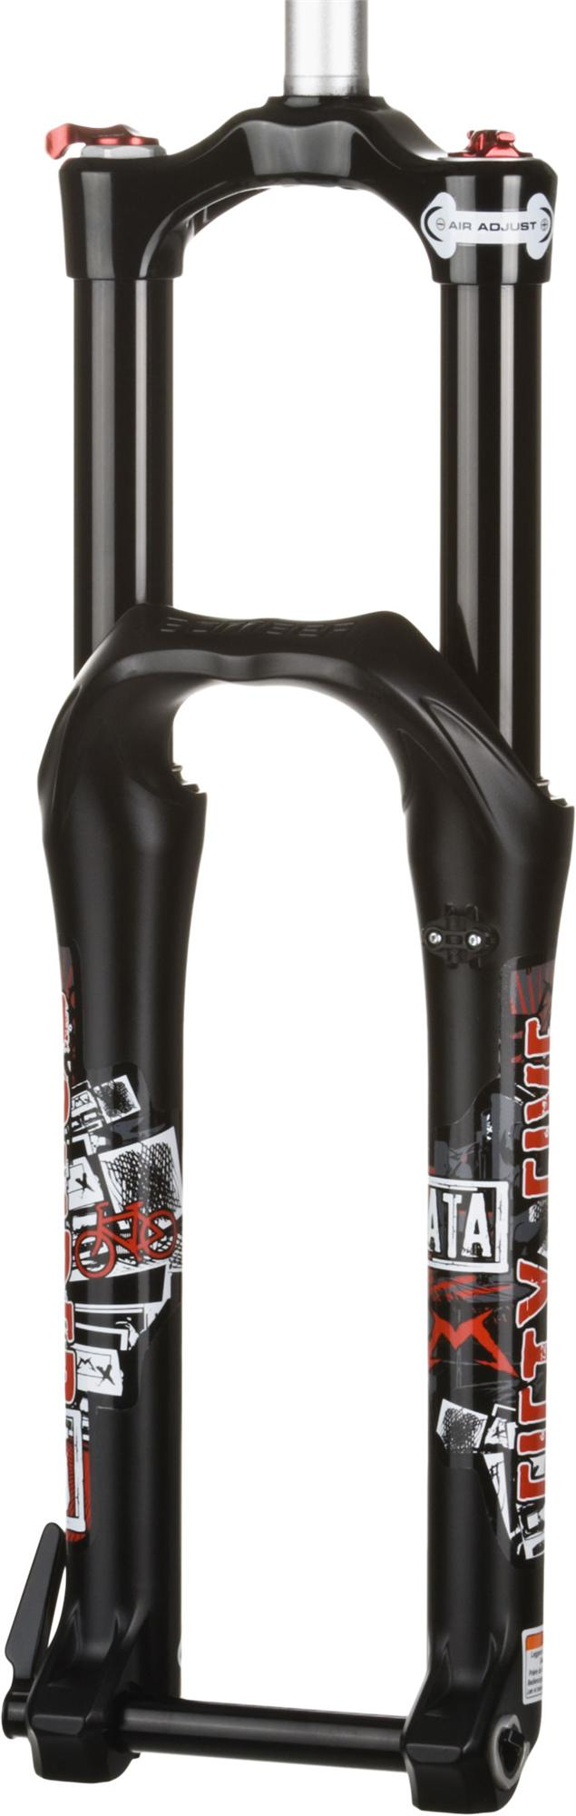
Figure 18: Marzocchi Bomber 55 ATA front mountain bike fork

Since the initial size constraints were developed during the Fall semester of 2012, the project team has acquired a Marzocchi Bomber 55 ATA front mountain bike fork (Figure 18). The Bomber 55 has outer stanchion diameter of 35 mm. Although the bomber 55 has greater stanchion diameter, the damper housing cartridge remains 24 mm, making the Bomber 55 compatible with the designs developed last semester.

Piston Head
Edited since November 30, 2012
The damper piston shown in Figure 18 (not to scale) is a sketch of the design. The piston head is 23 mm in diameter and 127 mm (5 inches) in length. As discussed above, the inner diameter of the damper housing is 24 mm; therefore, the piston head must be 23 mm in diameter. Also discussed above, the damper housing has a length of one foot and the travel requirement of the damper is four inches; therefore, the piston head can be no longer than eight inches. The project team decided on 127 mm (5 inches) piston head length. Smaller piston head length is possible; however, larger length will assist in constructing compartments in the piston head for the electromagnets. The piston head will be made of lightweight aluminum. Four orifices will be drilled through the piston head to allow MR fluid flow. Each orifice has a diameter of 3mm. Typical orifice size is between 0.5-3 mm in the majority of MR fluid devices [17].

Figure 19: Basic dimensions of MR damper piston head
Piston head:
23 mm diameter
Orifice:
3 mm diameter
Piston head:
127 mm long
Piston rod

Shown in Figure 19 is a cross-sectional view of the MR damper piston head.

Since the Fall semester of 2012, the project team has constructed an actual MR damper piston head (Figure 20). Figure 20 shows the electromagnet core to the constructed piston head.
Aluminum orifice tube: 3 mm diameter

Aluminum disc: 23.8 mm diameter
¼ inch by 20 thread steel hex nut
¼ inch low carbon steel rod
Figure 20: Basic dimensions of the constructed MR damper piston head
As discussed above, the damper housing within the mountain bike fork acquired for the project has inner diameter of 24 mm. The damper head has a largest diameter of 23.8 mm (0.983 in.). The electromagnet core consists of a one quarter inch low carbon steel rod and two one quarter inch by twenty thread steel hex nuts. Not shown in Figure 20 are the low carbon steel bars used to close the magnetic field on the outside of the aluminum orifice tubes. Also not shown in Figure 20 is the coil wrapped around the low carbon steel rod. The constructed piston head has 150 windings of 22 gauge magnet wire. A magnetic field would desirably travel down the low carbon steel rod, into the hex nut, through the aluminum orifices tubes, and close through the low carbon steel bars. Aluminum has poor magnetic properties as magnetic fields pass easily through aluminum; therefore, aluminum is used for the end caps and orifice tubing of the piston head. When in operation, the orifice tubes are filled with MR fluid. The magnetic field passing through the orifice tubes will align the iron particles in the MR fluid and change the damper characteristics of the fluid.
Orifice for MR fluid to flow
Lines of magnetic flux

Lines of magnetic flux closing through the iron core

Coils of wire wrapped around an iron core

Piston rod (electromagnet wires fed through piston rod)

Figure 21: Cross-sectional view of the MR damper piston head

The orifices allow MR fluid to flow freely through the piston head in the absence of a magnetic field. When the electromagnet is activated, a magnetic field is closed through an iron core. The magnetic field polarizes the iron particles, which forces the iron particles to form columnar structures in the direction of the magnetic field lines. The desired magnetic field strength for the coils to produce would be 1 tesla. This ensures that the MR fluid would generate the viscosity needed to simulate ideal damper fluid characteristics.

Electromagnet
An electromagnet consists of several components. It consists of a ferrous material wrapped with a coil of wire and a current that runs through the coil of wire. We are capable of changing the magnitude of the magnetic field with the sensors attached to the bike which would then change the yield stress of the MR fluid.

$$B=\frac{μ_{0}μ_{r}nI}{L}$$
MR fluid is controlled and adjusted by an electromagnet. The strength and size of a magnetic field generated by an electromagnet can be determined by: the number of turns in the coil (n), the current running through the coil (I), the length of the coil (L), the magnetic permittivity of free space, the magnetic permittivity of an iron core, and the distance between the electromagnet and a piece of metal (g) [18].

Accelerometers
Accelerometers are electrochemical devices used to measure acceleration. Accelerometers will be utilized in the MR damper control system to sense factors such as up or down hill travel, bicycle lean, velocity, rider weight, and type of terrain. Some important considerations when selecting an accelerometer include: Output type, number of axes, Maximum swing, sensitivity, bandwidth, impedance/buffering issues [19].
The ADXL278, ADXL312, and ADXL326 were evaluated using the following criteria: output type, number of axes, maximum swing, bandwidth, cost, and low voltage supply. Criteria is evaluated on a one to five scale with one being the least desirable option and five being the most desirable option. The results are presented below in Table 11.
Table 11: Accelerometer evaluation chart
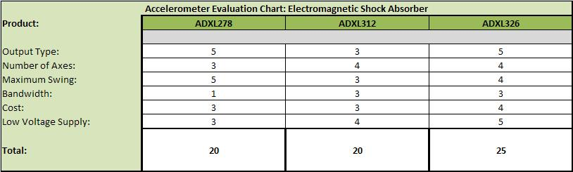
As seen from Table 11 above, the ADXL326 is the most desirable accelerometer with a total score of 25. The main advantages of the ADXL326 over the other two are the low cost and low voltage supply. The ADXL312 shares some common features with both the ADXL278 and ADXL326. The only advantage of the ADXL278 over the other two is it has a higher maximum swing.
The ADXL326 from Analog Devices INC measures acceleration and the output is an analog signal. It is a 3 axis device, which may be more than necessary for this first generation control system. The range of the ADXL326 is from -16 g to 16 g. The device sensitivity is rated at 57 mV/g with an accuracy of 10%. The bandwidth is rated at 1.6 KHz. Like the microcontroller, the advantages of the ADXL326 are low cost, an operating temperature range of -40 to 85 degrees Celsius, and low voltage supply.
The ADXL323 is a micro electromechanical system (MEMS) type accelerometer. The basic structure of a MEMS accelerometer consists of its housing, a seismic mass, and numerous fingers. The housing is simply the enclosure of the device. The seismic mass is a piece of silicon capable of motion. Each set of three fingers consists of two stationary fingers with a movable finger in between. The finger located in the center is attached to the seismic mass. The configuration of the three fingers, act as a differential capacitor. MEMS devices sense acceleration through the changes in capacitance. An accelerative force causes the seismic mass and center finger to move. The motion of the seismic mass and finger causes current to flow. The amount of current is correlated to acceleration value [20].

Microcontroller Unit
The microcontroller Unit (MCU) is the brain of the control system. The major components of a MCU include: the central processing unit (CPU), memory devices, input/output (I/O) ports, internal clocks, and Buses for exchanging information. A basic MCU block diagram is presented in Figure 20.
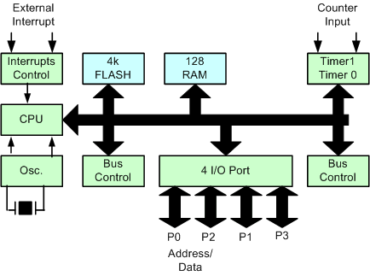
Figure 22: MCU block diagram
The CPU carries out various instructions such as input/output (I/O), basic arithmetic, and logical operations. Various memory devices are used in today’s MCUs. Typical memory devices include: read only memory (ROM), random access memory (RAM), and flash memory. Today’s MCU contains several ports to interface I/O devices. Modern MCUs contain at least one internal clock; however it is not uncommon to find multiple clocks, each operating at different frequencies. In order for all the MCU’s devices to communicate, at least one bus must be present [21].
The MSP430G2553 and ATMega328 microcontrollers were evaluated using the following criteria: MCU speed, memory capacity, the number of I/O ports, on chip ADC, low power consumption and cost. Criteria is evaluated on a one to five scale with one being the least desirable option and five being the most desirable option. The results are presented below in Table 12.
Table 12: Microcontroller evaluation chart
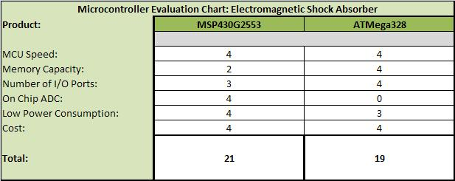
As seen in Table 12, the MSP430 is the most desirable microcontroller with a total score of 21. The advantage of the ATMega328 was a larger memory capacity and move I/O ports. Even with more memory capacity and more I/O ports, the MSP430 is still a sufficient microcontroller. The key advantage of the MSP430 is the on chip analog to digital converter.
The MSP430G2553 from Texas Instruments is a 16 bit microcontroller capable of speeds up to 16 MHz. The microcontroller has 16 KB of flash memory and 512 B of SPRAM. The MSP430G2553 also contains two 8 bit I/O ports. There is an on chip clock system, two 16 bit general purpose timers, and a watchdog timer. Additional features that make the MSP430 an ideal microcontroller for the MR damper control system are: on chip 10 bit analog to digital converter (ADC) with 8 channels, low power consumption, an operating temperature range between -40 to 85 degrees Celsius, and low cost.

Electronic Control System
Edited since November 30, 2012
The Electronic control system consists of the ADXL326 accelerometer, MSP430G2553 microcontroller, a voltage divider, and voltage sources to power these devices. The schematic for the electronic control system and its interfaces is presented below.

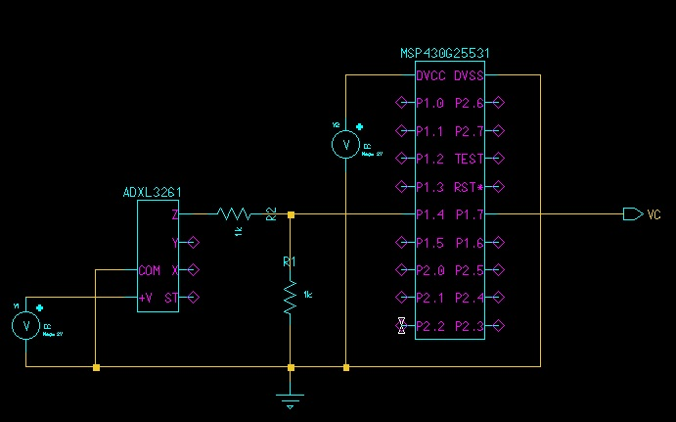
Figure 23 Electronic Control System

The ADXL326 requires a 3V source of power. The output is the vertical reading from the accelerometer’s Z-axis. The maximum power output at 16g is 3V, therefore a voltage divider was designed to scale down the voltage that would not over power the microcontroller. The microcontroller requires a 3V source of power. The output of the microcontroller will supply the desired voltage to a voltage controlled current source, that will in turn supply current to the electromagnet.

Voltage Controlled Current Source
Edited since November 30,2012
A voltage controlled current source (Figure 23 [22]) is a circuit which allows a current device (in our case an electromagnet) to be controlled with a small control voltage [22].
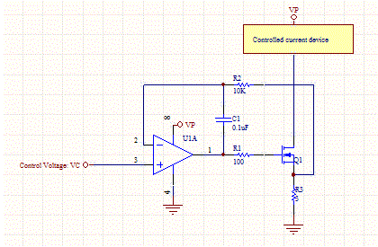
A small control voltage (VC) from the microprocessor controls the current through R3 which is the current through the electromagnet. The voltage drop across R1 and R2 can be neglected as essentially no current flows through those resistors. The op-amp's negative feedback will adjust the current through the MOSFET until the voltage across R3 is equal to the control voltage [22], making the current to the electromagnet equal to VC/R3.
Figure 24: Voltage controlled current source

Budget
Table 13 shows the estimated budget and bill of materials for the design of the electronic control system, electromagnet, and MR damper.
Table 13: Bill of Materials
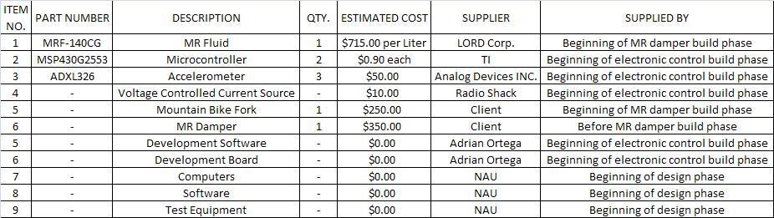

As indicated in Table 13, The majority of the estimated expenses are projected to be from the MR fluid and fabrication of the MR damper. The MR fluid is to be purchased from LORD Corp. The electronic control system components are to be purchased from Texas Instruments and Analog Devices INC. The Fabrication of the piston and MR damper is yet to be determined. Any change in materials and unexpected costs will be discussed with you before and action is taken.

Schedule/Deliverables
Below is a complete calendar and summary of work done on the project prior and subsequent to the proposal deadline.
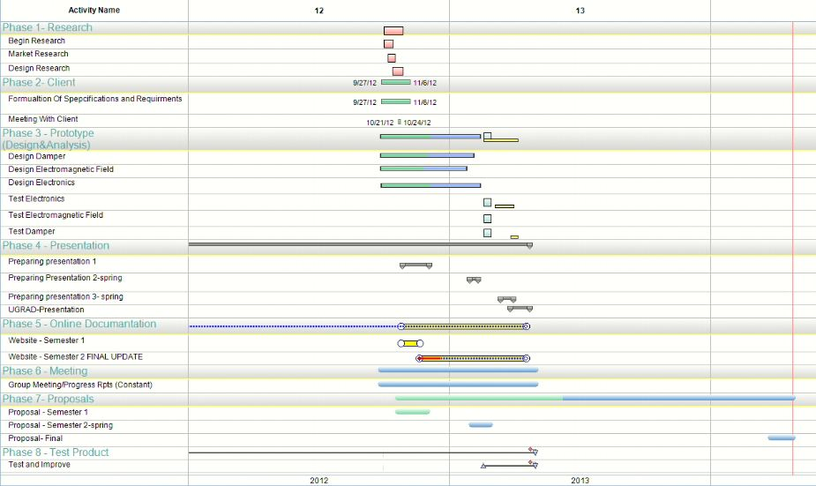
The design process for this project has been divided into eight phases. Phase one includes initial research, market research and design research. Phase two includes the formulation of specifications and requirements. Phase three consists of designing the damper, electromagnet, electronics and testing said devices for optimal performance. Phase four consists of preparation of the first and second presentations. Phase five consists of online documentation and construction of the website. Phase six consists of documenting and recording all meetings. Phase seven consists of the completion of the first and second proposal. Phase eight is the test phase of our project.

Completed phases consist of all of phase one, phase two, the design of the prototype, presentation one, splash page of the website, and the proposal document.

References

[12] LORD Corporation. (2012). MRF-122EG magnetorheological fluid. [Online] Available: http://www.lord.com/products-and-solutions/magneto-rheological-%28mr%29/product.xml/1644
[13] LORD Corporation. “MRF-122EG magnetorheological fluid,” LORD Corp., Cary, NC, Tech. Rep. DS7027, 2008.
[14] LORD Corporation. “MRF-132DG magnetorheological fluid,” LORD Corp., Cary, NC, Tech. Rep. DS7015, 2011.
[15] LORD Corporation. “MRF-132DG magnetrheological fluid,” LORD Corp., Cary, NC, Tech. Rep. DS7012, 2008.
[16] LORD Corporation. (2012). LORD Magnetorheological (MR) [Online] Available: http://www.lord.com/products-and-solutions/magneto-rheological-%28mr%29.xml
[17] Wikipedia. (2012). Magnetorheological fluid [Online] Available: http://en.wikipedia.org/wiki/Magnetorheological_fluid
[18] Easycalculation.com. (2012). Solenoid coil electromagnetic force calculator. [Online] Available: http://easycalculation.com/engineering/electrical/solenoid-force.php
[19] Dimension Engineering LLC. (2012). A Beginner’s Guide to Accelerometers [Online] Available: http://www.dimensionengineering.com/info/accelerometers
[20] Mike Szczys. (2012). The Engineer Guy Explains How MEMS Accelerometer Chips Work [Online] Available: http://hackaday.com/2012/05/22/the-engineer-guy-explains-how-mems-accelerometer-chips-work/
[21] Wikipedia. (2012). Microcontroller [Online]. Available: http://en.wikipedia.org/wiki/Microcontroller
[22] Daycounter, Inc. (2004). Voltage controlled current source-current servo, [Online] Available: http://www.daycounter.com/Circuits/Current-Servo/Current-Servo.phtml

Acceptance Document
If the there are any changes, discrepancies or questions applicable to the proposal please contact Michael Doty (mcd62@nau.edu)
If no changes are needed please sign the proposal and return the proposal before December 14th, 2012. If the proposal isn’t received by the date listed above, the team will assume the proposal has been accepted.

Point of contact
Craig Olson (client) will recognize Michael Doty as the point of contact for the team. If Craig Olson (client) wishes to designate a new point of contact, Craig Olson (client) must notify the team within 72 hours.

Liability
By signing below, Craig Olson (client) understands that the team and all its members are held harmless against any legal action as a result of work performed or not performed on the MR fluid damper system project.

Ownership
Upon completion of this project Craig Olson (client) will own 100% of the rights to this project.

Proposal Changes
Prior to accepting this document Craig Olson (client) can request changes to the document. Once the proposal is accepted both parties must agree to changes done to the proposal.

Continued Support and Work

Upon completion of this project the team and all of its members will no longer be obligated to provide any support or complete any additional work on the MR fluid damper system.

Team Signatures:

____________________________________________________________
Date
____________________________________________________________
Date
____________________________________________________________
Date
____________________________________________________________
Date

Client Signature:
____________________________________________________________
Date

